<BMI & BF test>

# 0. High Level Description:

This program is to test your body health condition , the values reflect your BMI and Fat level.

You input the values of your height, weight, age and gender to get your BMI and Adult Body Fat.

# 1. Contract:

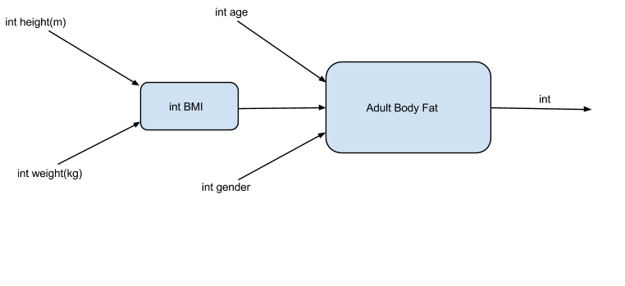

# Purpose:

User input their height and weight to get BMI level. Secondly, there bodyBMI value, age and gender will affect their bodies’ fat level.

weight (kg) / (height (m) * height (m)) = BMI

BodyBMI * 1.2 + 0.23 * age - 5.4 - 10.8 * gender = Adult body fat

to determine the your BMI and Fat percentage of your body in order to help you manage your body and diet as well as work-out plan.

# 3. Test Plan:

Test categories:

* BMI>0
* BMI<0
* BMI=0
* Adult Body Fat >0
* Adult Body Fat <0
* Adult Body Fat =0

**(All of results have been rounded down to the nearest numbers )**

|  |  |  |  |  |  |
| --- | --- | --- | --- | --- | --- |
| input1 | input2 | input3 | input4 | output1 | output2 |
| **height(m)** | **weight(kg)** | **age** | **gender** | **expected**  **BMI** | **Expected Adult fat** |
| 1 | 10 | 20 | 1 | 10.0 | 0.4% |
| 1 | -1 | 1 | 1 | -1.0 | -17.17% |
| 1 | 22.5 | 0 | 2 | 22.5 | 0.0% |
| 1 | 0 | 1 | 1 | 0.0 | -15.97% |
| 1 | 0 | 540 | 11 | 0.0 | 0%(this result is different in BlueJ) |
| 144 | 1200 | -20 | 0 | 0.0578 | 0%(this result is different wrong in BlueJ) |

**There are at least two BUGs in my code. When the parameter(age) is so big or is negative numbers, the result could be different as it is suppose to be.**

# 4. Algorithm idea:

The BMI for a person is defined as their body mass divided by the square of their height—with the value universally being given in [units](http://en.wikipedia.org/wiki/Units_of_measurement) of kg/m２, which means the weight per m２on your body. Thus, we can generally estimate your body shape.

Adult body fat must consider age and gender as the function’s variables, because the fat of a human body will accurately increase with age increasing and female and male are different as well.

As the formulas:

weight (kg) / (height (m) * height (m)) = BMI

bodyBMI * 1.2 + 0.23 * age - 5.4 - 10.8 * gender = Adult body fat

**Note: the deliverables of the remaining coding steps are given in the accompanying BlueJ project.**